**Wideband Digital Channelizer**

**(WBC)**



|  |
| --- |
| Wideband channelization provides 1GHz input BW  Programmable on-board applications  Enhanced channel flexibilities enable soft allocation of payload resources (Bandwidth, Power and Frequency)    Auto Gain Control (AGC) per channel  Interference rejection capacity / blocking unused spectrum  Applicable for any communicating mission/Frequency bands (including: S, X, Ku, Ka)  Customized for Multi Port Amplifier (MPA) and eliminate the need for OMUX section  High speed serial data interfaces providing inter connectivity  Scalable and Modular design concept |



**Wideband Digital Channelizer**

**(WBC)**

|  |  |
| --- | --- |
| Parameter | WBC Unit Performance |
| Available Bandwidth | **2 x 0.5GHz (Input) to 0.5GHz Output** |
| Channel BW | **Variable from 2.75 MHz to 125 MHz / 2.75MHz step** |
| Channel Connectivity | **Any to Any (Unicast, Multicast, Broadcast)** |
| Gain Control per Channel | **50dB per channel / 0.1dB step (MGC/AGC)** |
| Digital I/O Interface | **8 Inputs (4 Active) x 250MHz**  **8 Outputs (4 Active) x 250MHz** |
| Input Ref. Freq. | **100MHz / TCXO** |
| Power Consumption | **45W for a single card, 180W for S/S (4+1R)** |
| Mass | **1.8Kg for a single card, 9Kg for S/S (4+1R)** |
| Dimensions [mm] | **Card - 46(D) x 320(L) x 136(H)**  **S/S - 230(D) x 320(L) x 136(H)** |

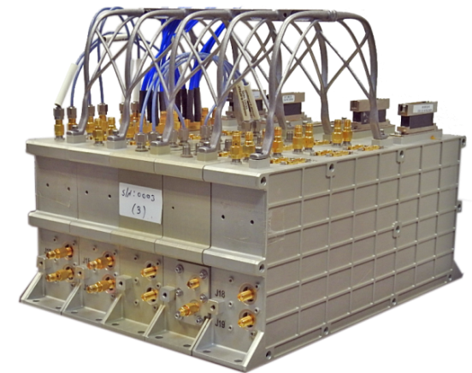

**Contacts:**

IAI Digital Products

[Products@iai.co.il](mailto:Products@iai.co.il)

**Wideband Digital Channelizer**

**(WBC)**

Example Demo for NSL

